Turn in an assignment
You turn in your work online in Classroom. Depending on the type of assignment and attachments, you’ll see Turn in or Mark as Done.
If you need to edit work that you turned in, you can unsubmit the assignment before the due date, make your changes, and resubmit. However, any assignment turned in or marked done after the due date is recorded as late.
Computer AndroidiPhone & iPad

Turn in an assignment
You can attach one or more files to your work. You can also open new files in Google Docs, Slides, Sheets, and Drawings, work in them, and then attach them to your assignment. However, you can’t attach a file that you don’t own.
- Go to classroom.google.com.
- Click the classClasswork.
- Click the assignmentView assignment.
- To attach an item:
  - Under Your work, click Add or createselect Google Drive , Link , or File .
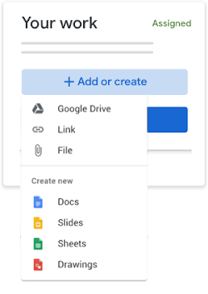
  - Select the attachment or enter the URL for a link and click Add.
- To attach a new document:
  - Under Your work, click Add or createDocs , Slides , Sheets , or Drawings .
A new file attaches to your work and opens.
  - Click the file and enter your information.
- (Optional) To remove an attachment, next to the attachment's name, click Remove .
- (Optional) To add a private comment to your teacher, under Private comments, enter your comment and click Post .
- Click Turn In and confirm.
The status of the assignment changes to Turned in.
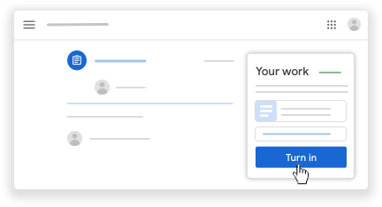
Important: If you get an error message when you click Turn in, let your instructor know.

Turn in a quiz assignment
- Go to classroom.google.com.
- Click the classClasswork.
- Click the assignmentView assignment.
- Click the form and answer the questions.
- Click Submit.
If the form is the only work for the assignment, the status of the assignment changes to Turned in.
- If there's more work to do for the assignment, click Open assignment.

Turn in an assignment with a doc assigned to you
If your teacher attached a document with your name in the title, it’s your personal copy to review and edit. As you work, your teacher can review your progress before you click Turn in.
- Go to classroom.google.com.
- Click the classClasswork.
- Click the assignmentView assignment.
- Click the image with your name to open the assigned file.
- Enter your work.
- On the document or in Classroom, click Turn in and confirm.
The status of the assignment changes to Turned in.
Important: If you get an error message when you click Turn in, let your instructor know.

Mark an assignment done
Important: Any assignment turned in or marked done after the due date is recorded as late, even if you previously submitted the work before the due date.
- Go to classroom.google.com.
- Click the classClasswork.
- Click the assignmentView assignment.
- (Optional) To add a private comment to your teacher, under Private comments, enter your comment and click Post .
- Click Mark as done and confirm.
The status of the assignment changes to Turned in.

Unsubmit an assignment
Want to make changes to an assignment that you already turned in? Just unsubmit the work, make the changes, and turn it in again.
Important: Any assignment turned in or marked done after the due date is marked late, even if you previously submitted the work before the due date. If you unsubmit an assignment, be sure to resubmit it before the due date.
- Go to classroom.google.com.
- Click the classClasswork.
- Click the assignmentView assignment.
- Click Unsubmit and confirm.
Note: This assignment is now unsubmitted. Turn it in again before the due date.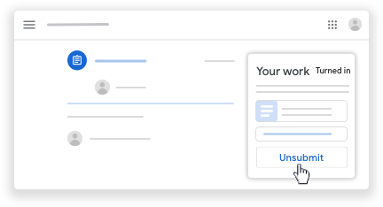

Related articles
- See your work for a class
- How attachments are shared in Classroom
- Work with a doc assigned to you
- Google Docs Help Center
- Use a screen reader with Classroom on your computer

Post to the class stream
This article is for students. Teachers go here.
If your teacher allows it, you can communicate with your class in the class stream in the following ways:
- Post—Information or a question that you add to the class stream.
Example: When do we visit the museum?
- Comment—A response to a post or comment.
Example: We go next Friday.
- Reply—A response to a comment that mentions the person who made the comment.
Example: +commenter’s name Thanks!
If you don't want to post in the class stream, you can send a private comment to your teacher on an assignment or question.
Note: If your teacher mutes you, you can’t post, comment, or reply to comments. Only teachers can unmute a student.
Computer AndroidiPhone & iPad

Create a post
To ask a question or to share information with your teacher and classmates, create a post.
- Go to classroom.google.com.
- Click the class.
- On the Stream page, click Share something with your class.
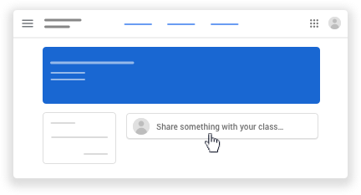
Note: If you don’t see Share something with your class, your teacher turned off permissions to post.
- Enter what you want to say and click Post.

Add an image, file, video, or link to your post
You can attach items to your post, such as images, files, Google Drive items, YouTube videos, or links.
- Follow the steps above to create a post.
- Click Addchoose an option:
Attachment type | Directions
Image or file | - Click File .  - Drag files to attach or select them from your computer and click Upload.
Google Drive | - Click Google Drive .  - Select your file and click Add.
YouTube | Search for a video:  - Click YouTube .  - Enter keywords and click Search .  - Click the videoAdd.  Attach a video link:  - Click YouTube .  - Click URL.  - Enter the URL and click Add.
Link | - Click Link .  - Enter the URL and click Add Link.
- Click Post.
Note: If you see a message that you don’t have permission to attach a file, click Copy. Classroom makes a copy of the file to attach to your post and saves the copy to the class Drive folder.

Delete a post
You can only delete your own posts.
If you delete a post, all the comments associated with it are also deleted. You can't undo this action. Teachers can delete anyone’s post and see all deleted posts.
- Go to classroom.google.com.
- Click the class.
- On the post, click More Delete.
- Click Delete to confirm.

Add a comment to a post
If your teacher allows, you can comment on other posts and comments. Teachers can delete comments.
Note: Comments are text only. You can’t add pictures, links, or videos.
- Go to classroom.google.com.
- Click the class.
- In a post, click Add class commententer your comment.
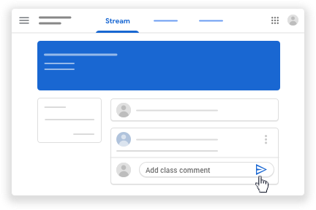
Note: If you don’t see Add class comment, your teacher turned off permissions to comment.
- Click Post .

Reply to a comment
When you reply to a comment, the person you reply to is automatically mentioned. You can reply only to comments, not posts.
- Go to classroom.google.com.
- Click the class.
- Point to the comment and click Reply .
- Enter your reply and click Post .

Delete a comment
You can only delete your own comments. Teachers can see deleted comments.
- Go to classroom.google.com.
- Click the class.
- On the comment, click More Delete.
- Click Delete to confirm.

Send a private comment to your teacher
You can send a private comment to your teacher that only they can see from an assignment or question. You can see your teacher’s response when you open the assignment or question. If you delete a private comment, your teacher can still see it.
- Go to classroom.google.com.
- Click the class.
- Choose an option:
  - On the Stream page, click the assignment or question.
  - On the Classwork page, click the assignment or questionView assignment or View question.
- Click Add private comment.
- Enter your commentclick Post .

Related article
- Turn in an assignment
- Answer a question

