Source: https://support.google.com/edu/classroom/answer/6020260?hl=en

How attachments are shared in Classroom
As a teacher, you can attach documents, links, and images to assignments for your students. Classroom works seamlessly with Google Docs, Google Drive, and Gmail.
As a student, you sign in to Classroom, see your assignments, and submit your work online. When you turn in your work, the teacher sees it on the Classroom Stream page.
All your Classroom activity, whether you’re a teacher or student, is online using a computer or mobile device.

The workflow in action
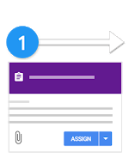 | 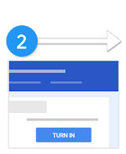 | 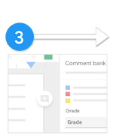 | 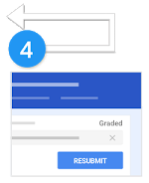
Teacher creates an assignment and attaches files. | Students attach materials or edit files from the teacher and turn in their work. | Teacher grades and returns the students' assignments. | Students see their grades and feedback.  Optional: Students can edit and resubmit.

Step 1: Teacher creates an assignment
As the teacher, you can post the assignment to the whole class or to a student or group, or to one or more classes. You can set a due date and attach files for students to work on.
When you attach a Drive file (document, slides, or sheets), you can choose to:
- Allow students to only view the file—Students can read the file but not edit it.
- Allow students to edit the file—Students share the same file and each student can edit it.
- Make a copy of the file for each student—Students get an individual copy of the file that has their name added to the document title, and they can edit it. When a student turns in the assignment, you see the file labeled with the student’s name.
As students work on an assignment, you can view their progress, add comments, and make edits in the documents.
Note: You have the same share options when you attach files to an announcement.
For instructions, go to Create an assignment or Create a question.

Step 2: Students turn in their assignment
As a student, you can work on the assignment by viewing a document, editing a shared document, or editing your individual copy of a document. You can attach files, links, or images to your work. When finished, you turn in your work.
Before the due date, you can unsubmit work, make changes, and resubmit it. After you turn in a file from Google Docs, Sheets, or Slides, only the teacher can see and edit your work.
For instructions, go to Turn in an assignment.

Step 3: Teacher grades and returns assignments
As the teacher, you can write notes on student work, add a grade, and return it with individual feedback for any student.
For instructions, go to Grade and return an assignment and Draw or write on student work.

Step 4: Students see their grades and can edit
As a student, you can see your grades. If your work includes a Drive file, you regain edit access to the file again and you can make improvements as required.
For instructions, got to See your work for a class.

Related articles

Teachers
- Attach files to an assignment
- Post to individual students or a group of students
- Attach files to an announcement

Students
- Attach files to an assignment
- See your work for a class
- See your overall grade for a class
- Work with a doc assigned to you

