Create an assignment
This article is for teachers.
When you create an assignment, you can post it immediately, save a draft, or schedule it to post at a later date. After students complete and turn in their work, you can grade and return it to the students.
Computer AndroidiPhone & iPad
Open all | Close all

Create and post assignments
Create an assignment
In classes created after April 17, 2019, posts to the Classwork page appear at the top.
When you create an assignment, you can:
- Post to one or more classes
- Post to individual students
- Add a grade category
- Change the point value
- Add a due date or time
- Add a topic
- Add attachments
- Add a rubric
- Turn on originality reports

Create an assignment
- Go to classroom.google.com.
- Click the classClasswork.
- At the top, click CreateAssignment.
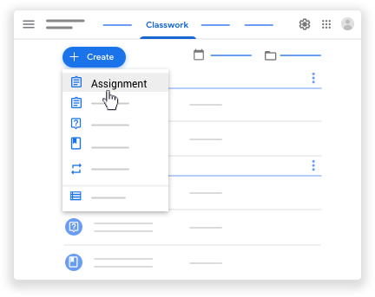
- Enter the title and any instructions.
You can continue to edit and customize your assignment. Otherwise, if you’re ready, see below to post, schedule, or save your assignment.

Post to additional classes
Assignments to multiple classes go to all students in those classes.
- Create an assignment (details above).
- Under For, click the Down arrow select the class or classes you want to include.
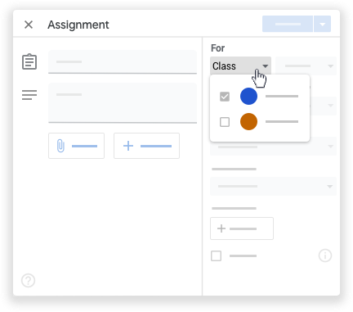

Post to individual students
Unless you’re posting to multiple classes, you can post an assignment to individual students. You can’t post to more than 100 students at a time.
- Create an assignment (details above).
- Next to All students, click the Down arrow All students again to deselect students.
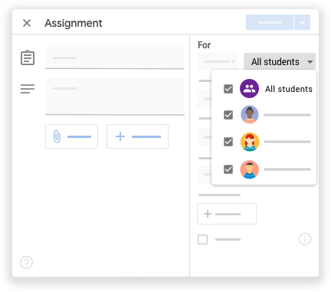
- Click a student's name to select them.

Add a grade category
Use grade categories to organize assignments. With grade categories, you and your students can see the category an assignment belongs to, such as Homework or Essays. Teachers also see the categories on the Grades page.
- Create an assignment (details above).
- Under Grade category, click the Down arrow select a category from them menu.
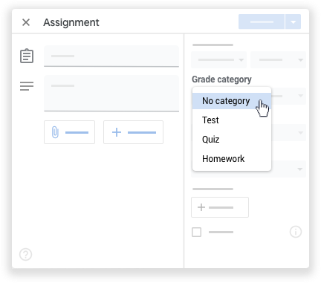
For more information on grade categories, go to Add a grade category to posts or Set up grading.

Change the point value
You can change the point value of an assignment or make the assignment ungraded. By default, assignments are set at 100 points.
- Create an assignment (details above).
- Under Points, click the value.
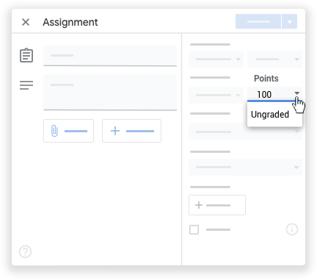
- Enter a new point value or select Ungraded.

Add a due date or time
By default, an assignment has no due date. To set a due date:
- Create an assignment (details above).
- Under Due, click the Down arrow .
- Next to No due date, click the Down arrow .
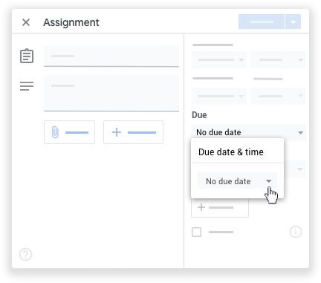
- Click a date on the calendar.
- (Optional) To set a due time, click Timeenter a time and specify AM or PM.
Note: Work is marked Missing or Turned in late as soon as the due date and time arrive. For example, for work to be on time at 9:00 AM, set the time due to 9:01 AM. For instructions to check work status, go to View student assignments.

Add a topic
- Create an assignment (details above).
- Under Topic, click the Down arrow .
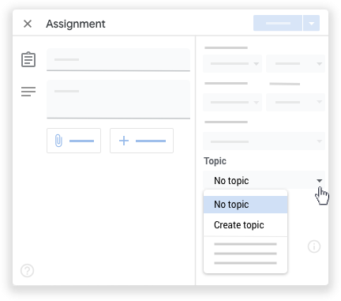
- Choose an option:
  - To create a topic, click Create topic and enter a topic name.
  - Click a topic in the list to select it.
Note: You can only add one topic to an assignment.
Learn more about how to add topics to the Classwork page.

Add attachments
You can add attachments to your assignment, such as files from your computer, Google Drive files, YouTube videos, or links.
- Create an assignment (details above).
- Click Addchoose an option:
Attachment type | Directions
File | - Click File .  - Select the file and click Upload.
Google Drive | - Click Google Drive .  - Select the item and click Add.  If you attach a Google Forms quiz and there’s no other attachment with the assignment, grades can be imported directly to the Student Work page.
YouTube | Search for a video:  - Click YouTube .  - Enter keywords and click Search .  - Click the videoAdd.  To attach a video link by URL:  - Click YouTube URL.  - Enter the URL and click Add.
Link | - Click Link .  - Enter the URL and click Add Link.
- If you see a message that you don’t have permission to attach a file, click Copy. Classroom makes a copy of the file to attach to the assignment and saves it to the class Drive folder.
- Next to the attachment, click the Down arrow and choose an option for how students interact with the attachment:
  - Students can view file—All students can read the file, but not edit it.
  - Students can edit file—All students share the same file and can make changes to it.
  - Make a copy for each student—Students get their own copy of the Google Docs, Sheets, or Slides file with their name added to the document title. You and the student can edit the document. When students turn in the assignment, they can’t edit the document until you return it to them.
Note: This option is only available before you post an assignment.
- (Optional) To delete an attachment, next to the attachment, click Remove .

Add a rubric
For instructions, go to Create or reuse a rubric for an assignment.

Turn on originality reports
For instructions, go to Turn on originality reports.
Post, schedule, or save a draft assignment

Manage assignments
Edit an assignment
Add a class comment to the assignment
Reuse an assignment
Delete an assignment

Related articles
- Create or reuse a rubric for an assignment
- Turn on originality reports
- Create a quiz assignment
- Create a question
- Use a screen reader with Classroom on your computer
Give feedback about this article

Post announcements to your students
This article is for teachers. Students go here.
You can post announcements to your class on the class stream. Announcements are posts with no assignments. You can use them to give notices or reminders to your students. Announcements appear in chronological order. If you want, you can move an older post to the top.
You can draft and schedule announcements and control who comments or replies to posts. If a student turns on notifications, they’ll get an email when you post an announcement.
Computer AndroidiPhone & iPad
Open all | Close all
Create an announcement
You can post announcements to one or more classes or to certain students in a class. You can also add attachments.

Post an announcement
- Go to classroom.google.com.
- Click the class.
- On the Stream page, click Share something with your class and enter your announcement.
You can continue to edit and customize your announcement. Otherwise, if you’re ready, see below to post, schedule, or save your announcement.

Post to additional classes
Announcements to multiple classes go to all students in those classes.
- On the Stream page, click Share something with your class.
- Next to For, click the Down arrow select the classes you want to include.
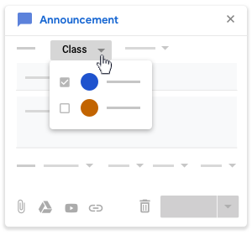
- Enter your announcement and click Post.

Post to individual students
Unless you’re posting to multiple classes, you can post an announcement to individual students. You can’t post to more than 100 students at a time.
- On the Stream page, click Share something with your class.
- Click All studentsAll students again to deselect students.
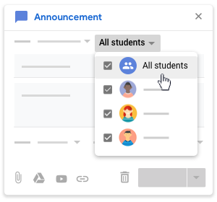
- Click a student’s name to select them.
On the Stream page, you can see the number of students the announcement was posted to.
- (Optional) To view the students’ names, on the announcement, click number students.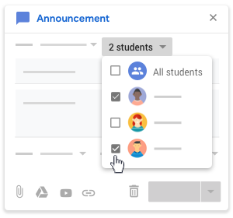

Add attachments
You can add attachments, such as Google Drive files, YouTube videos, or links, to your announcement. Google Drive items are view-only to students and editable by co-teachers. To change these sharing options, see Stop, limit, or change sharing.
- Follow the steps above to create a post.
- Click Addchoose an option:
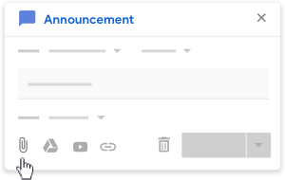
Attachment type | Directions
File | - Click File .  - Select the file and click Upload.
Google Drive | - Click Google Drive .  - Select the item and click Add.
YouTube | Search for a video:  - Click YouTube .  - Enter keywords and click Search .  - Click the videoAdd.  To attach a video link by URL:  - Click YouTube URL.  - Enter the URL and click Add.
Link | - Click Link .  - Enter the URL and click Add Link.
- If you see a message that you don’t have permission to attach a file, click Copy. Classroom makes a copy of the file to attach to the announcement and saves the copy to the class Drive folder.
- (Optional) To delete an attachment, next to the attachment, click Remove .
Post, schedule, or save a draft announcement
Add a class comment to an announcement

Manage announcements
Edit an announcement
Reuse an announcement
Delete an announcement
Move an announcement to the top

Related topics
- Set student permissions to post and comment
- Use a screen reader with Classroom on your computer

