Our Lifetime Service commitment to
Financial Education
To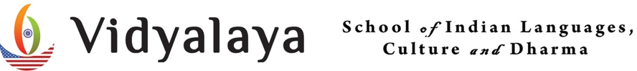
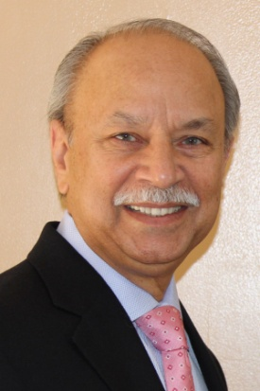

Manmohan “Billy” Singh is a Registered Representative of Park Avenue Securities LLC (PAS), 7 Hanover Square, New York, NY 10004. Securities products and services offered through PAS, 1-888-600-4667. Financial Representative of Guardian Life Insurance Company of America (Guardian), New York, NY. PAS is an indirect, wholly owned subsidiary of Guardian. The Forest Hills Financial Group, Inc. is not an affiliate or subsidiary of PAS or Guardian. PAS is a member of FINRA, SPIC. Cell: 516-557-1263
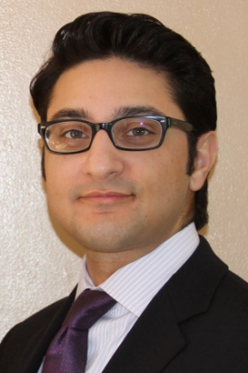
Deep Singh is a Registered Representative and Financial Advisor of Park Avenue Securities LLC (PAS), 95-25 Queens Blvd, 10th Floor, Rego Park, New York 11374. Securities products and services offered through PAS, 1-888-600-4667. Deep Singh is a Field Representative of The Guardian Life Insurance Company of America (Guardian), New York, NY. PAS is an indirect, wholly owned subsidiary of Guardian. Forest Hills Financial Group is not an affiliate of subsidiary of PAS or Guardian. PAS is a member FINRA, SIPC. Cell: 516-557-5648

